Task Report

Joining Tables in SQL
- Match employees to their machines
- Return more data
- Retrieve login attempt data

Task 1.
Match employees to their machines

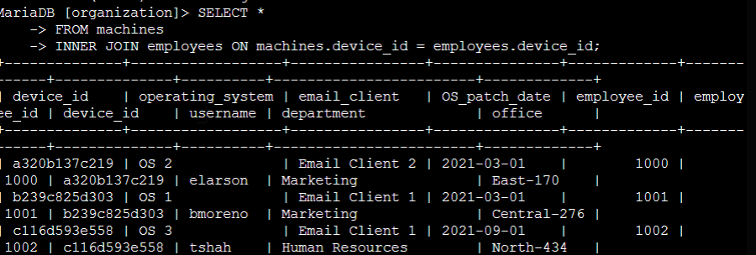
Command Semantics
    - SELECT *
FROM machines
INNER JOIN employees ON machines.device_id = employees.device_id; This command tells SQL to SELECT all (*) columns FROM the machines table. It then further commands SQL to only output rows where there is information in the device_id column of both tables

Task 2.
Return more data

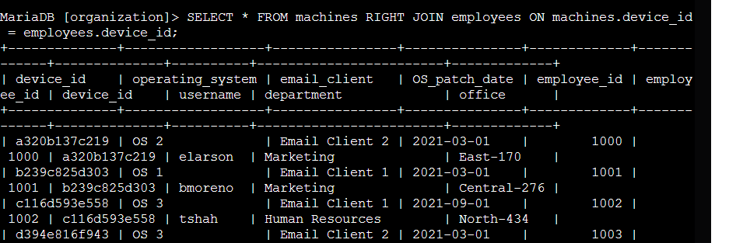
Command Semantics
    - SELECT *
FROM machines
LEFT JOIN employees ON machines.device_id = employees.device_id; This command tells SQL to SELECT all (*) columns FROM the machines table. It then further commands SQL to only output all columns from the machines table and only rows where there is information in the device_id column of both tables

Task 3.
Retrieve login attempt data

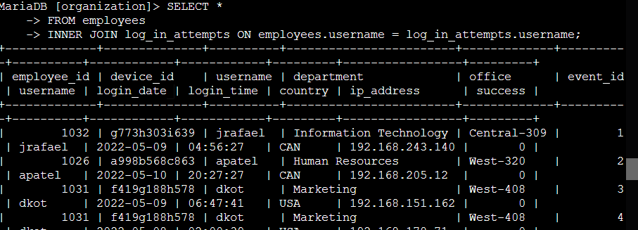

Command Semantics
    - SELECT *
FROM employees
INNER JOIN log_in_attempts ON employees.username = log_in_attempts.username; This command tells SQL to SELECT all (*) columns FROM the employees table. It then further commands SQL to only output data from the tables where there is an entry in the “username” column of both

Summary
We joined tables in three different ways – using two INNER JOIN, and a LEFT JOIN. This SQL skill is useful when collecting log data that is needed for various everyday tasks a Security Analyst might perform, such as investigating a Security Incident or recognizing a pattern of behavior in problem employees that could help in improving the security culture of an organization – hardening the company's overall security posture.

